Analyzing TED Talks Data

Team#6: Nidhishree Sanam & Sravani Ravulaparti

University of Maryland, Baltimore County

DATA 604: Data Management

Prof. Hang Yue, May 17th 2022

1. **INTRODUCTION:**

TED is a global community that welcomes people from all disciplines and cultures who want to learn and spread ideas to the world in the form of short powerful talks (18 minutes or less). We are convinced that ideas have the ability to alter people's minds, lives, and, ultimately, the world. TED originated in 1984 as a conference where Technology, Entertainment, and Design converged, and has since expanded to embrace nearly every topic imaginable, from science to business to global challenges, in over 100 languages. So, we have chosen this data to analyze more about the ted talk shows.

1. **OVERVIEW OF THE DATASET:**

We have collected this data from the Kaggle to drive data analysis on the Ted Talks. Here the data has been recorded from Feb 1984 to Feb 2022. The data set consists of Show title, Author/ Speaker of the show, number of authors for the show, Occupation of the author, date at which Show was conducted, Number of views, Number of likes, link to the Ted talk. This data set can be divided into two tables namely; the main table & the Author table. In the main table, the title of the show serves as a primary key while in the Author Table, Author_id serves as a unique identifier. In ted shows table it describes about the various shows conducted and ted author table describes about author details. There is a possibility that one author could performer one or more shows and each show could be performed by one or more authors. Therefore, we have created an Entity- Relationship Diagram to create a Relational Database table.

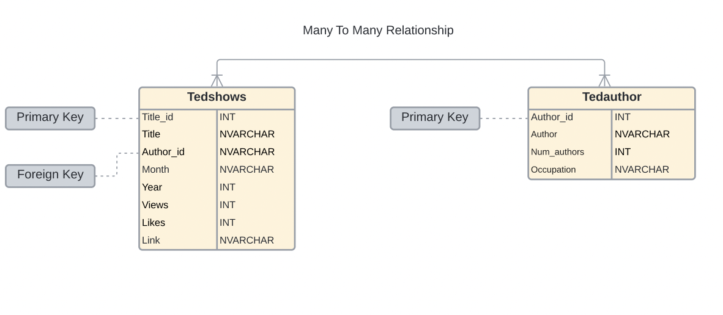

Fig 1

1. **EXTRACTION, TRANSFORMATION AND LOADING:**

AWS Glue is a fully managed ETL (Extraction, transformation and loading) service as it makes it simple and cost-effective to store the data, clean it, enrich it and move it reliably between various data sources. Advantages of AWS Glue include:

* To build a data warehouse to organize, cleanse, validate and format data.
* To run serverless queries against Amazon s3 data lake.
* To create event driven ETL properties.
* To understand your data source.

**Steps Followed:**

1. Collected data and divided the big data into two tables (tedshows, tedauthor).
2. Figured out relationships among data tables via Entity-Relationship diagram.
3. Loaded data files into AWS S3 bucket, later created database with S3 location in AWS Glue.
4. Created and run the crawler to extract the tables from the data files.
5. SQL codes will be written to query the data to check the popular shows based on the views & likes, to find most popular Ted talk speaker, Month & Year-wise Ted shows frequency using SQL Joins via Athena.
6. We have also created an AWS RDS, and connected it with MySQL workbench for querying the data from the tables.
7. Using this cleaned data, we have connected to Tableau to perform the data analysis and display the important information using graphs.
8. **TOOLS USED:**

**AWS RDS:** To host the MySQL

for Data Analysis

**AWS Athena**: To analyze data in Amazon S3 using standard SQL

**AWS** **Glue**: Toaccess the data and create table definitions

**AWS S3 Bucket:** To load the csv files into the cloud storage and to store all the output files in the cloud.

**Tableau:** For Visualization and Analysis

1. **DATA TABLES:**

* Tedshows: Title_id, Title, author_id, Month, Year, views, likes, link are columns.

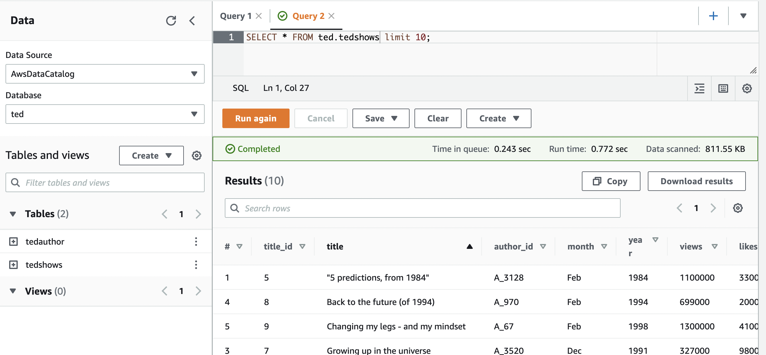

* Tedauthor: Author_id, author, Num_authors, Occupation are columns.

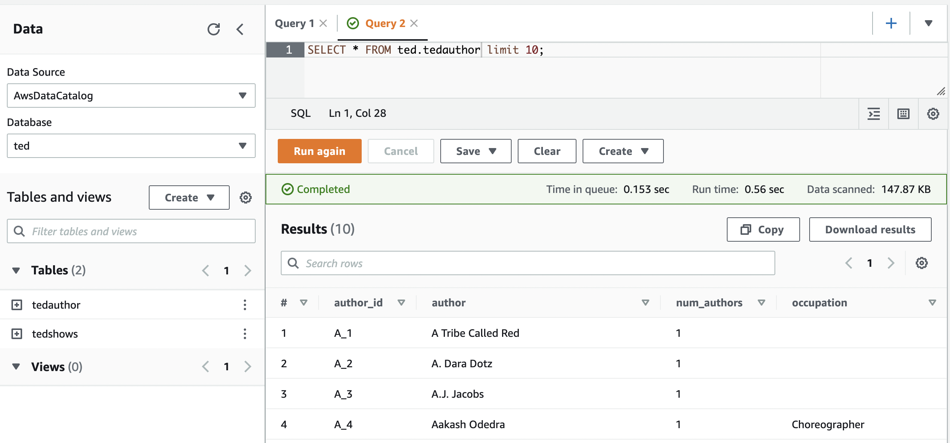

1. **AWS S3 BUCKET, AWS GLUE & AWS ATHENA:**

Created S3 bucket 🡪 Three folders have been created, 2 for datasets and 1 for the results.

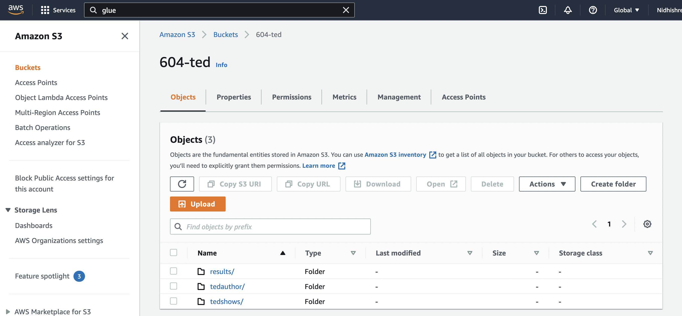

Created a database in AWS Glue.

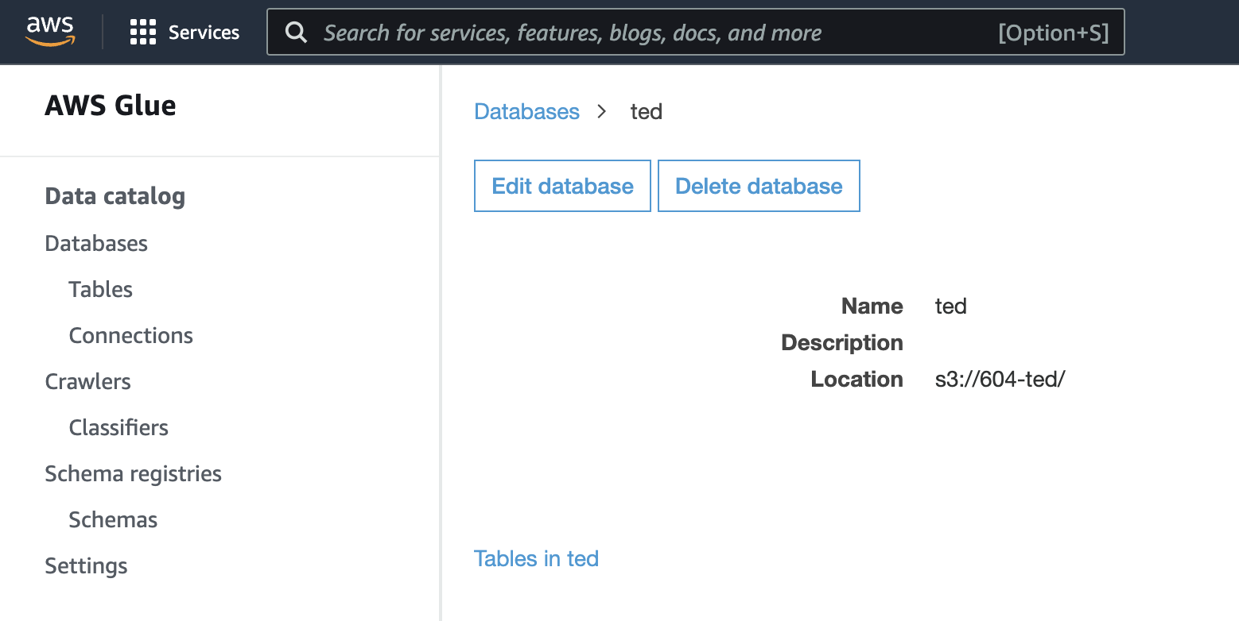

Created Crawler.

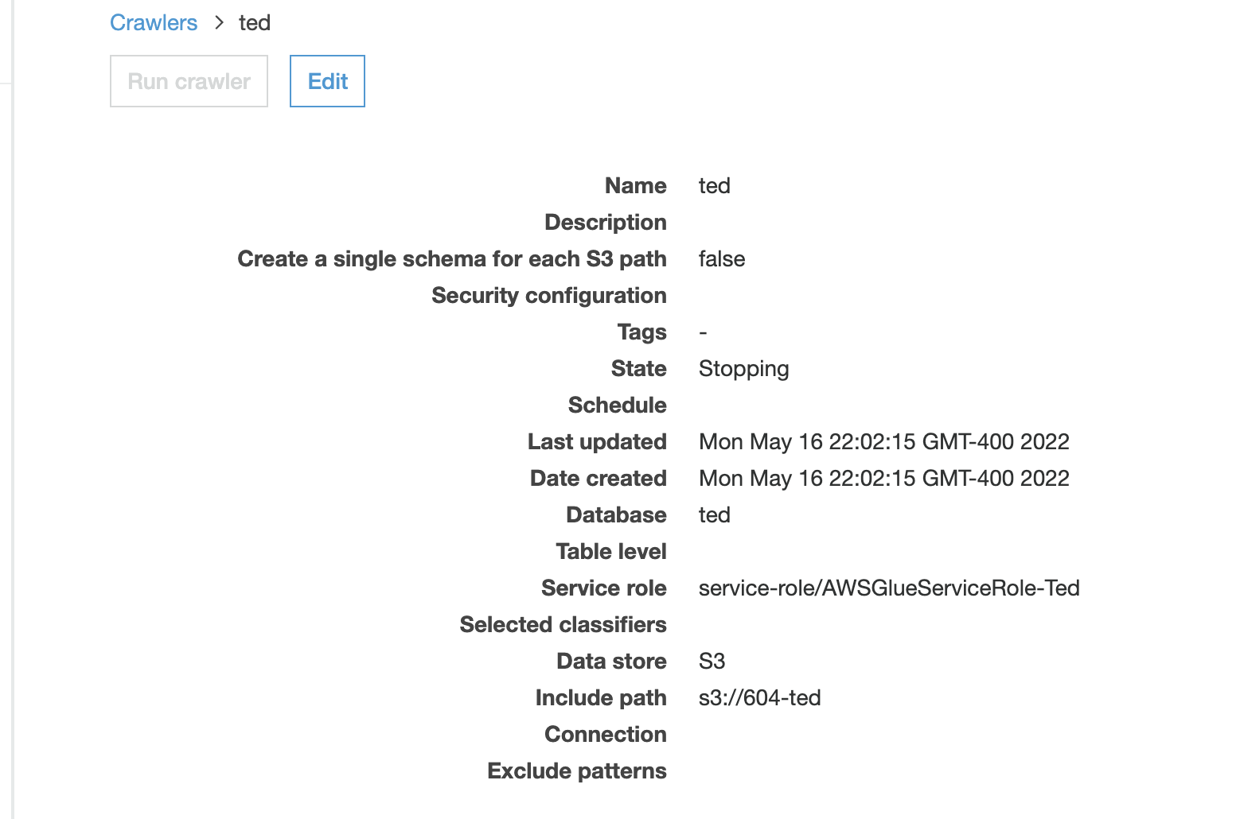

Run Crawler to create uploaded files as tables.

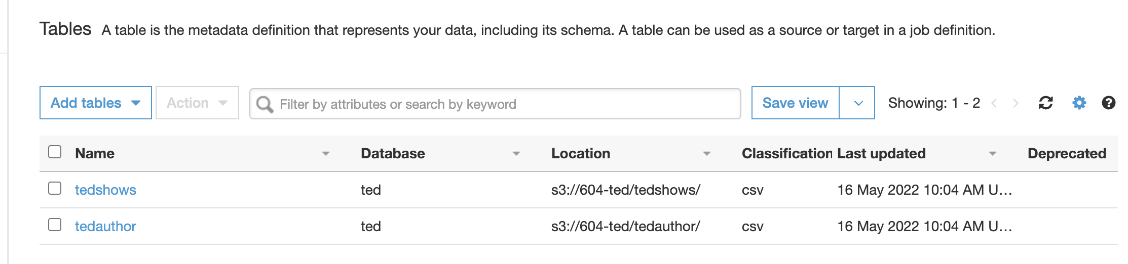

Connected to Athena for querying.

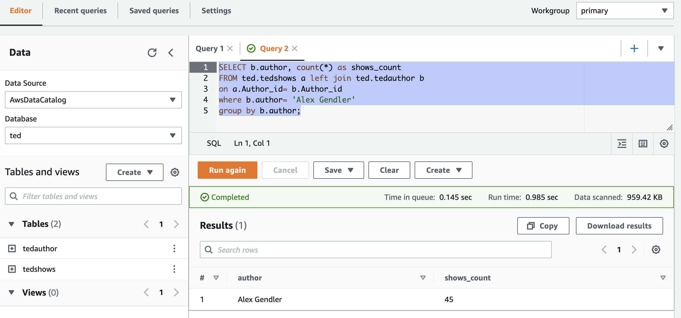

1. **AWS RDS:**

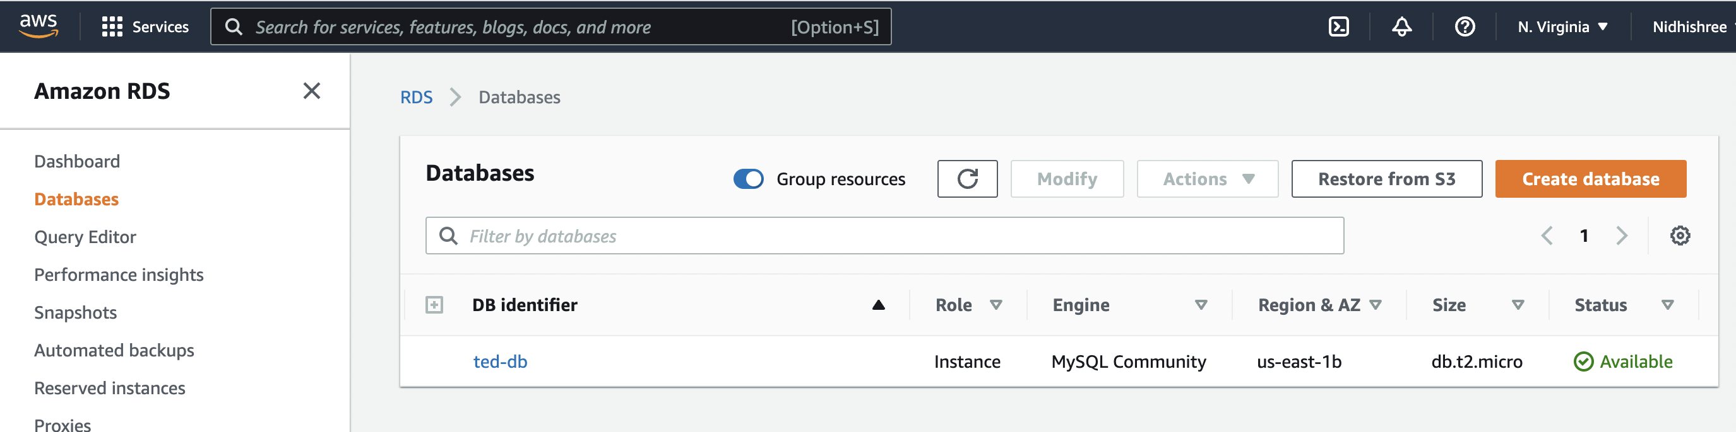

1. **DATA ANALYSIS USING RDS:**

Once the data is loaded into the tables, we have used Mysql workbench to connect to the AWS RDS and performed the analysis by SQL queries. Below are few queries executed.

* Query1: To find the top 10 ted talk shows based on Views.

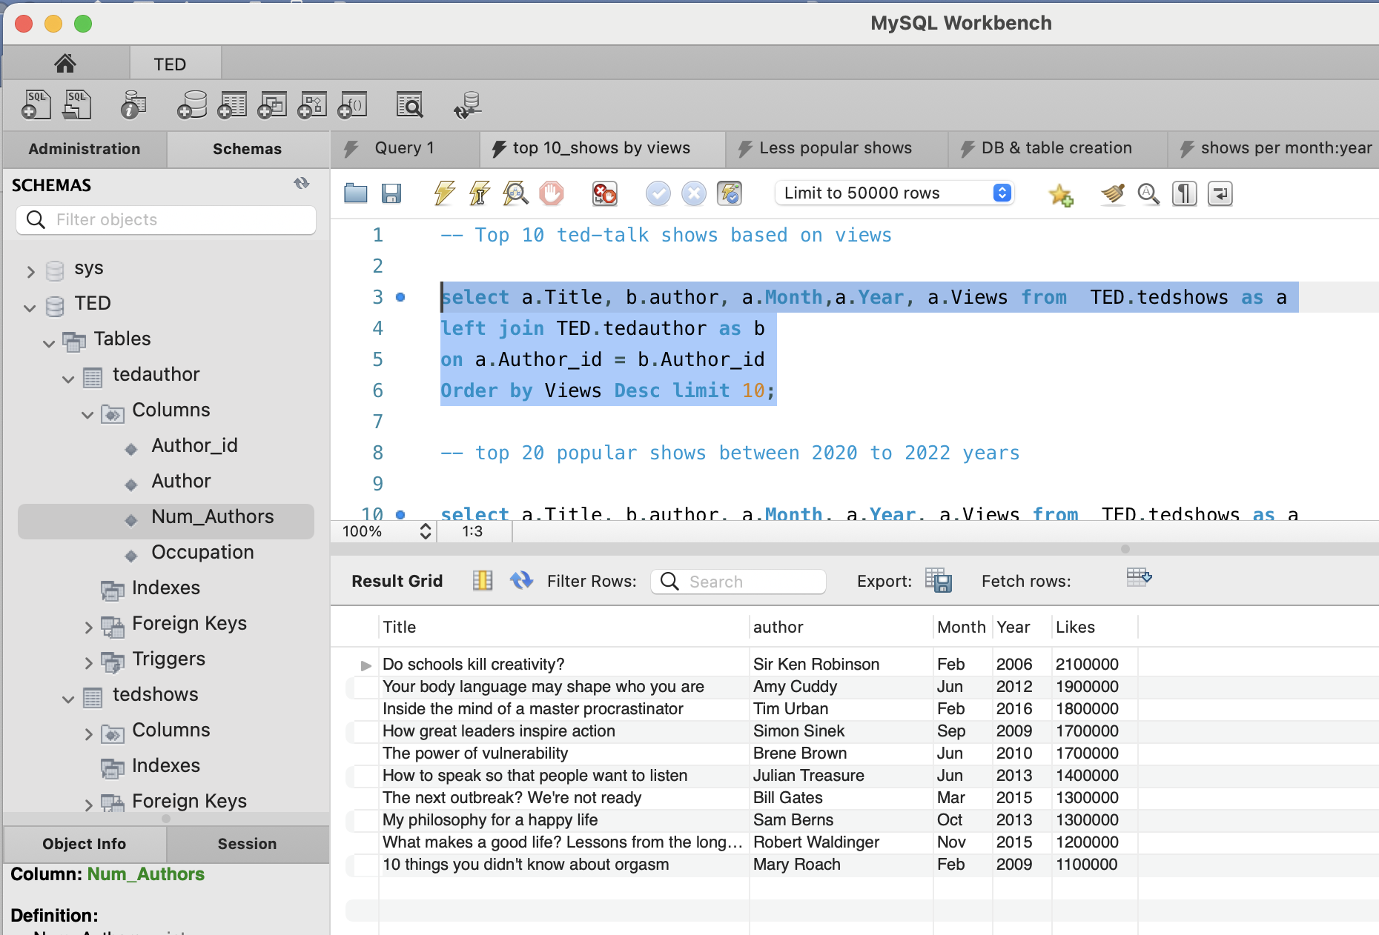

* Query2: To find the top 10 ted talk shows based on Likes.

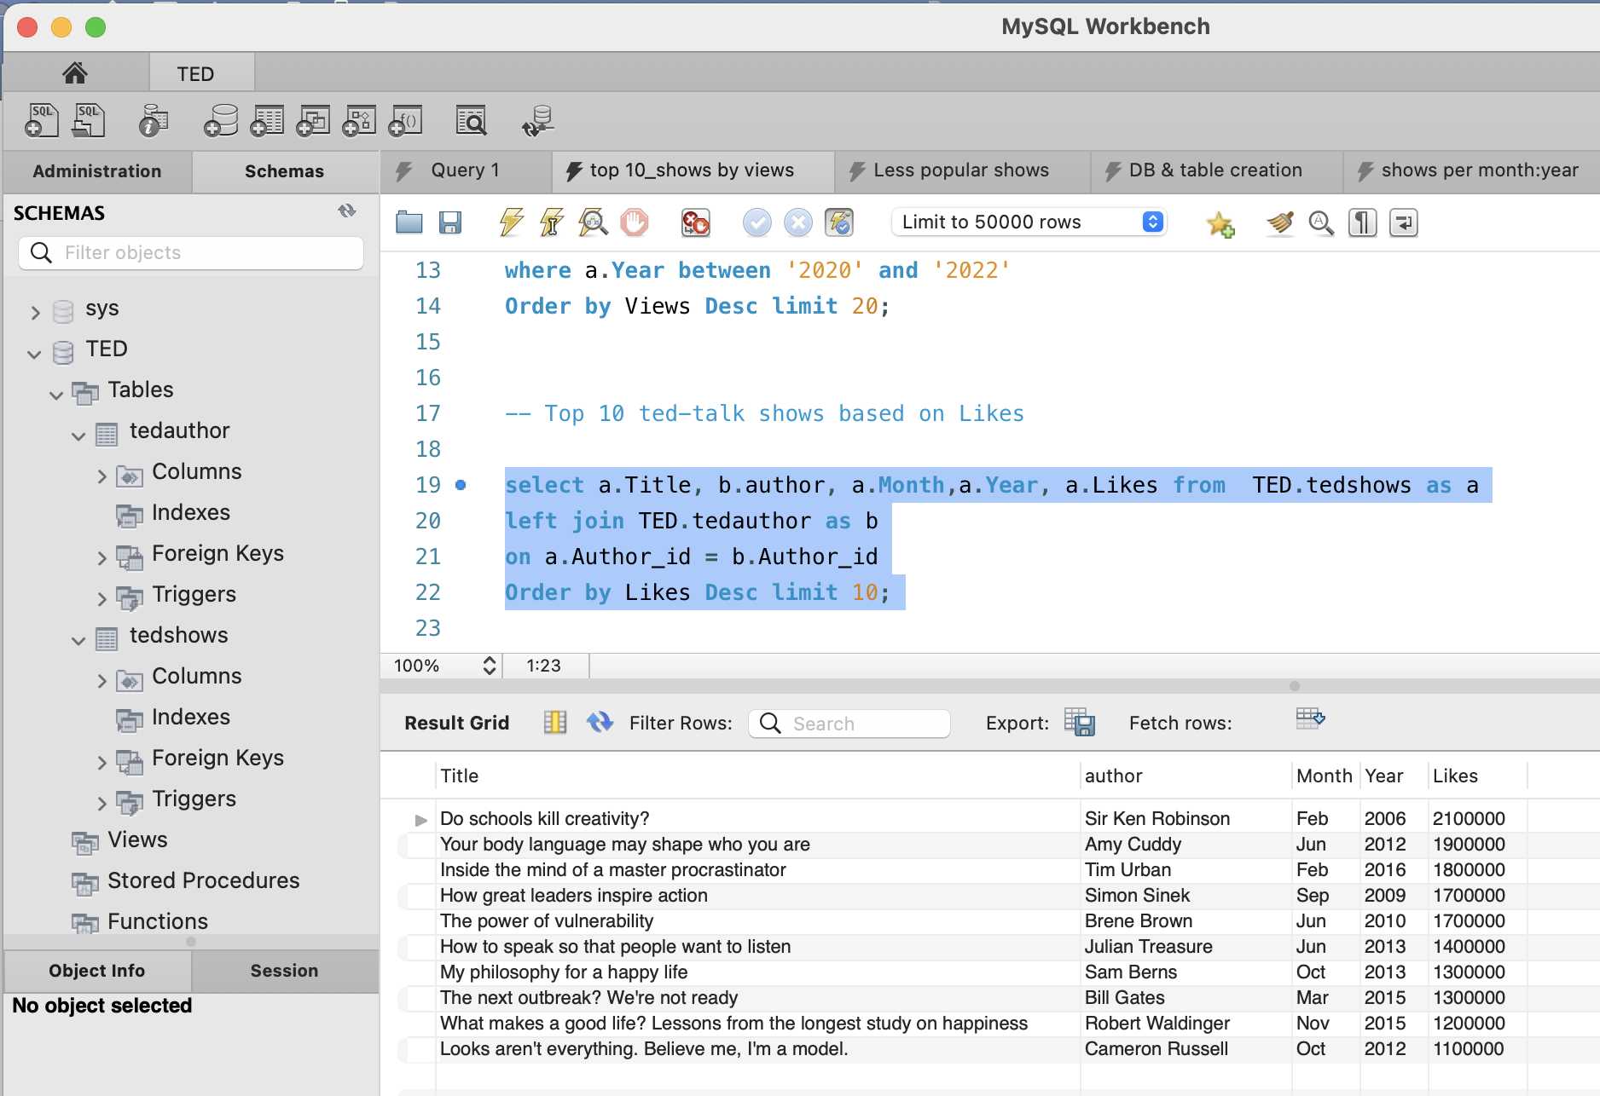

* Query3: To Find the popular shows in the recent times (2020 to 2022).

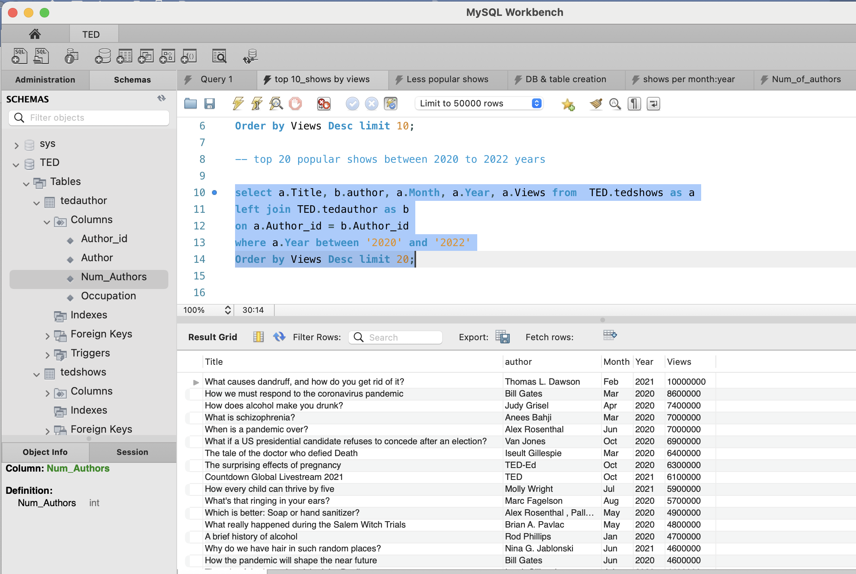

* Query4: To find 100 less popular shows based on Views and Likes.

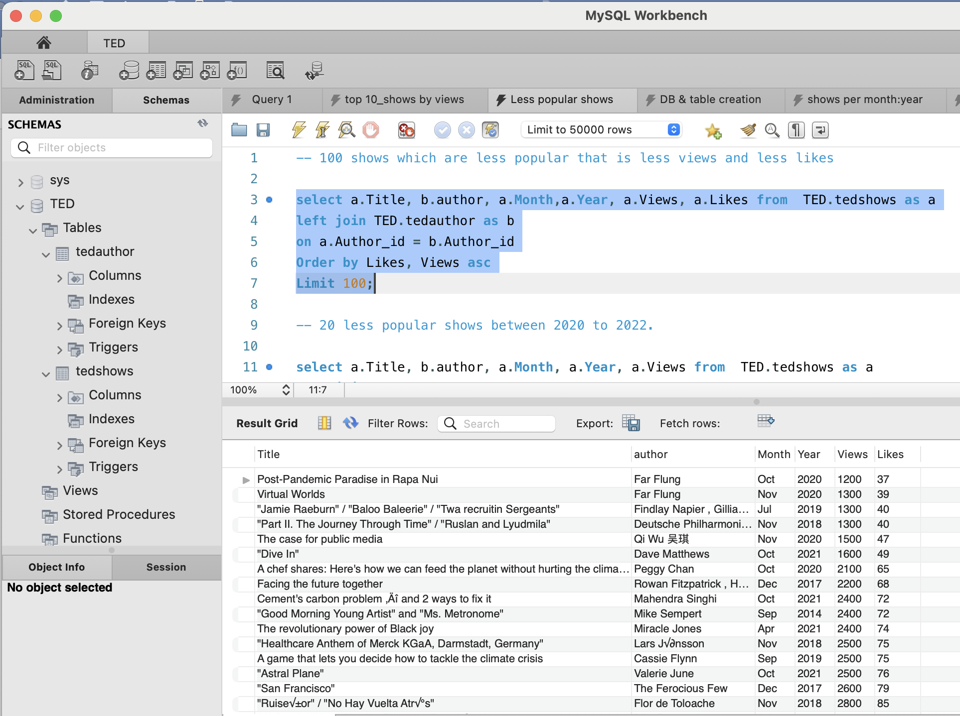

* Query5: To find the shows frequency per Month.

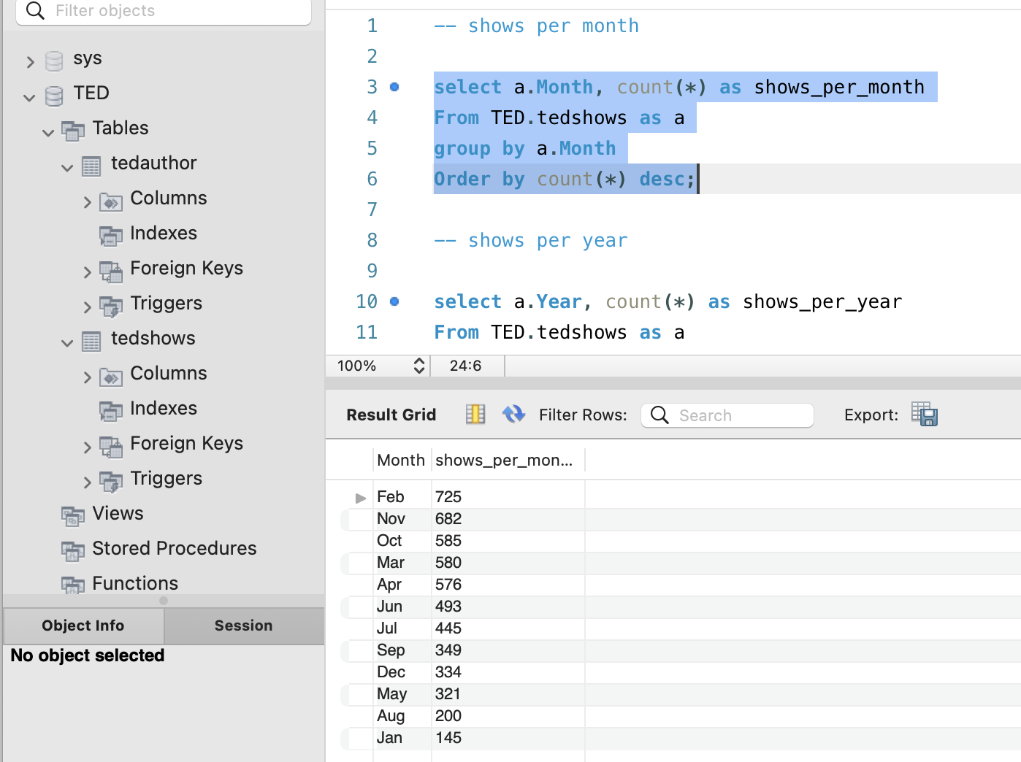

* Query6: To find the shows frequency per Year.

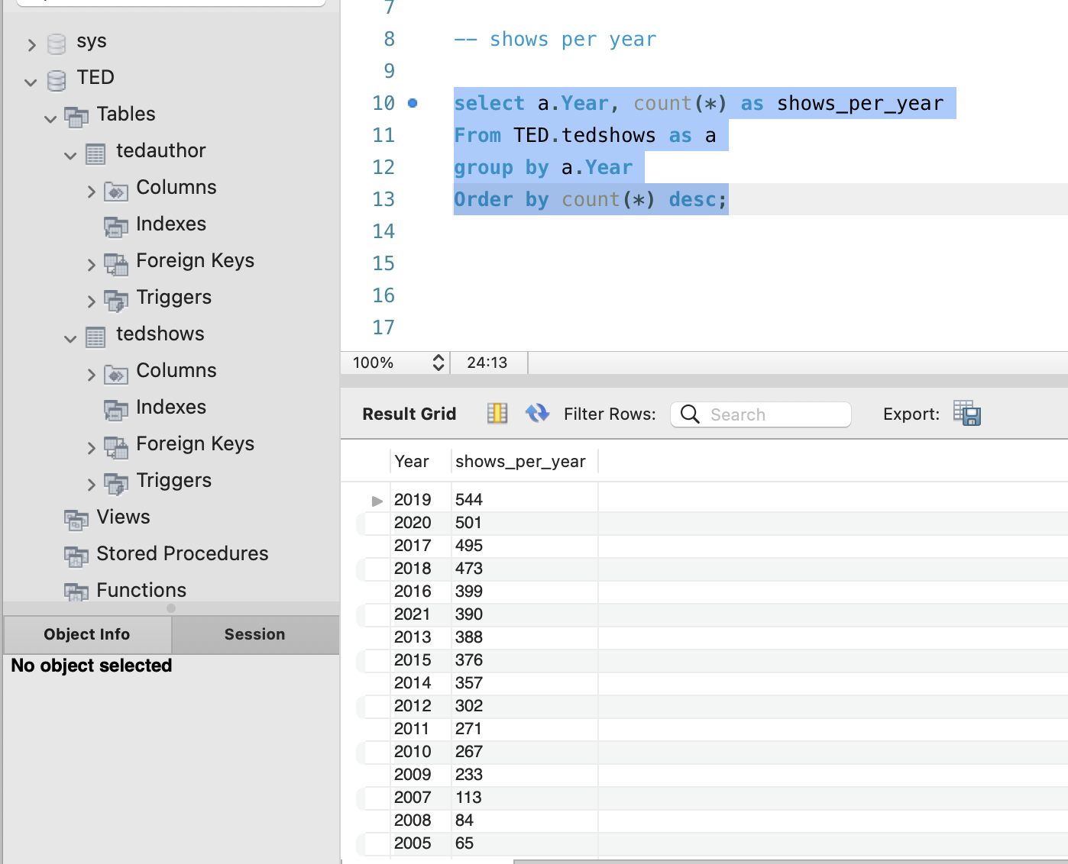

* Query7: To find number of shows with more than 1 speaker.

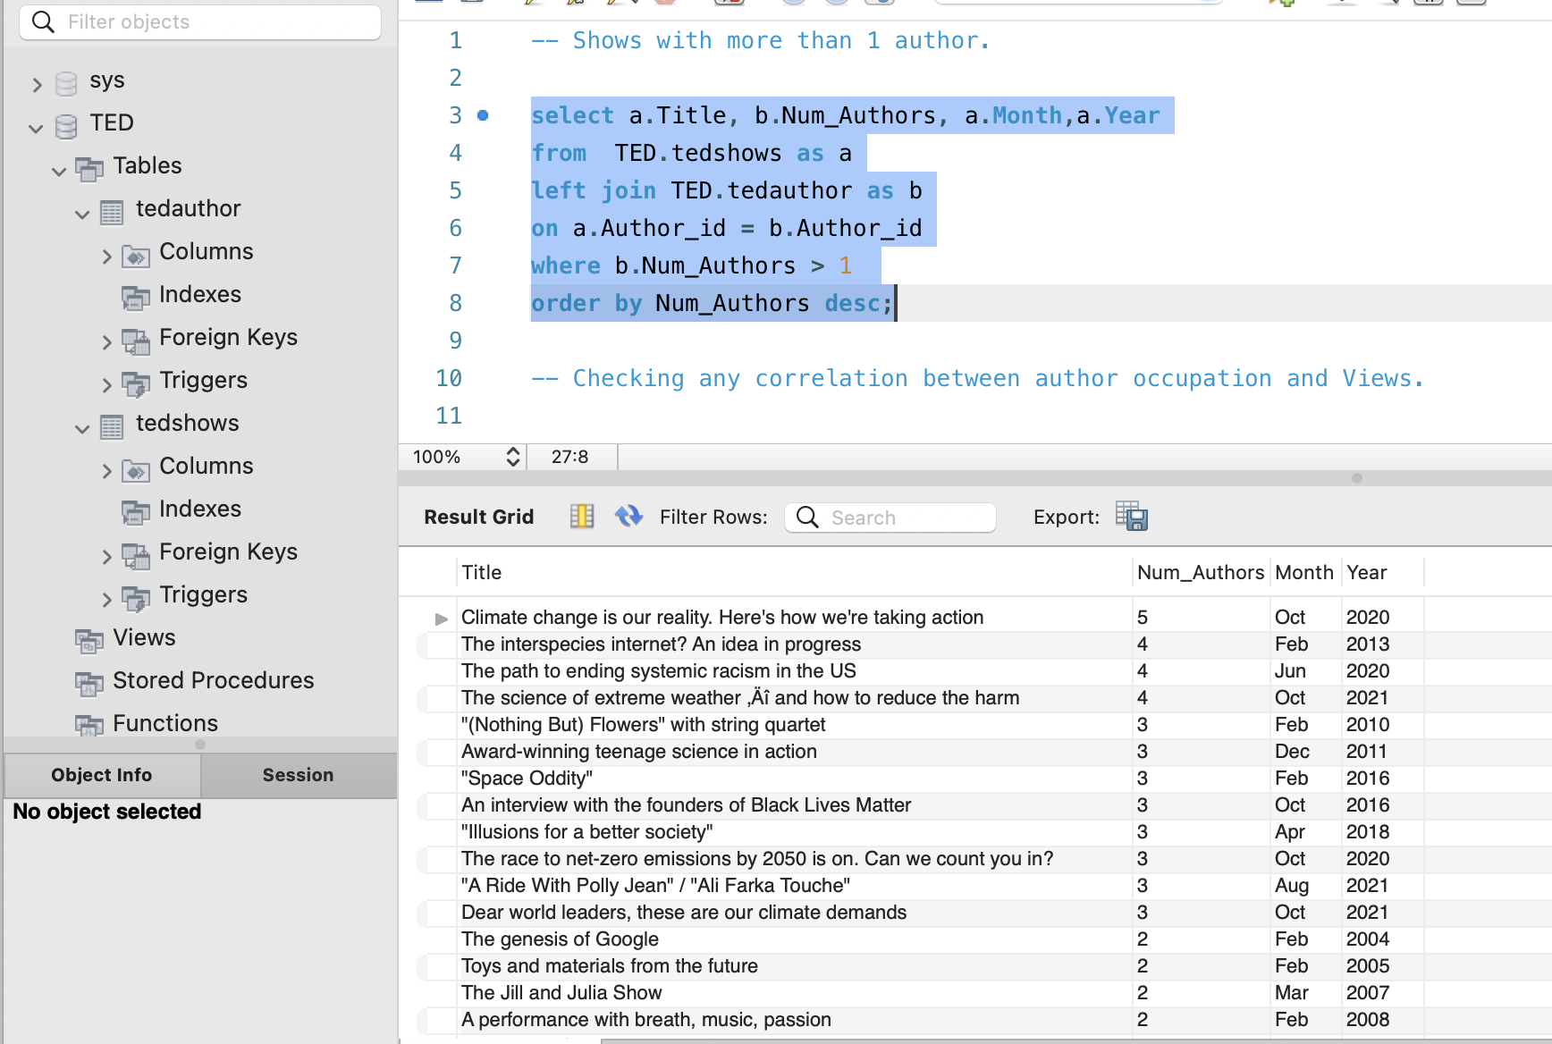

* Query8: To find total number of shows per number of speakers.

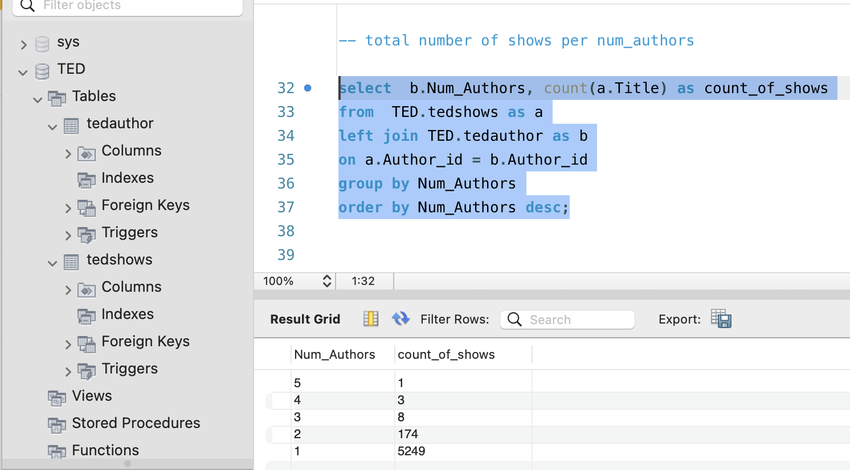

* Query9: average number of Likes per year.

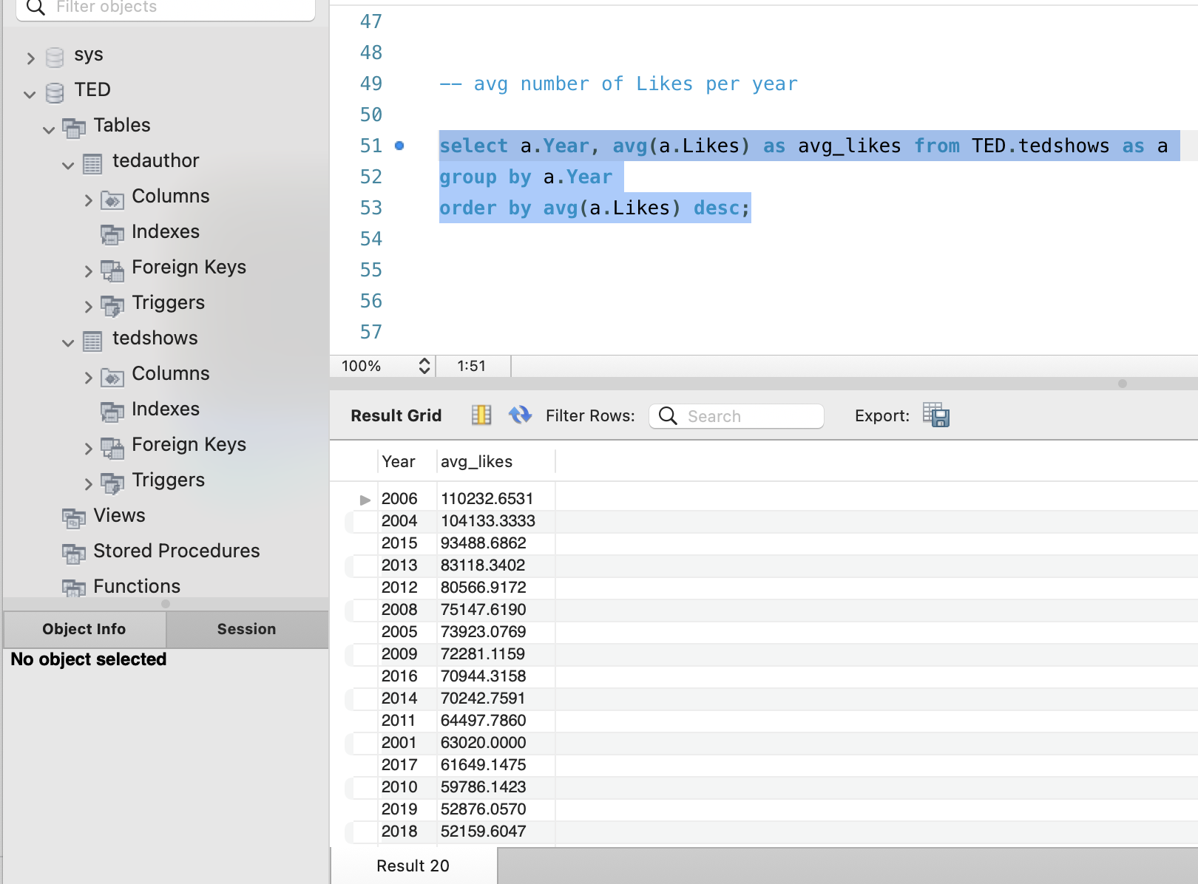

* Query10: To find number of shows based on author occupation.

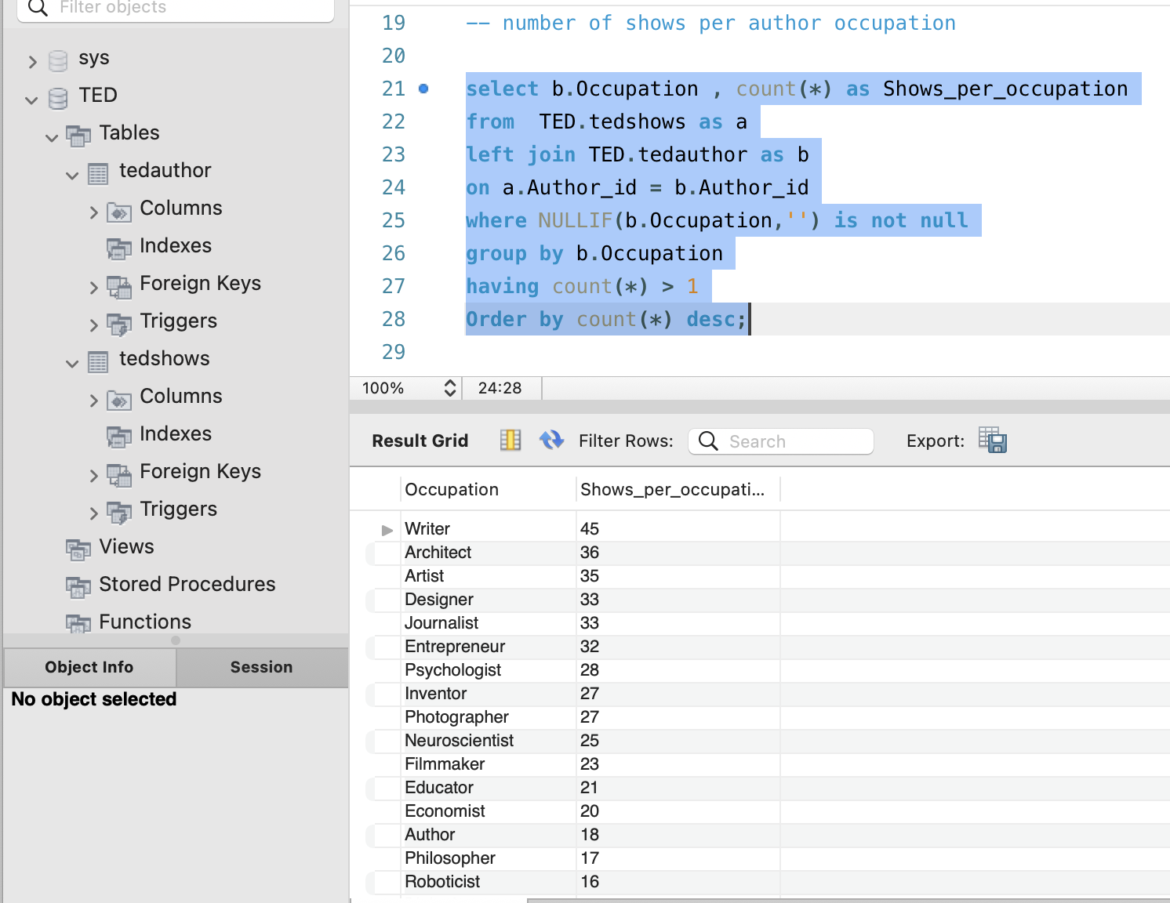

Query11: Total number of shows performed by each Speaker.

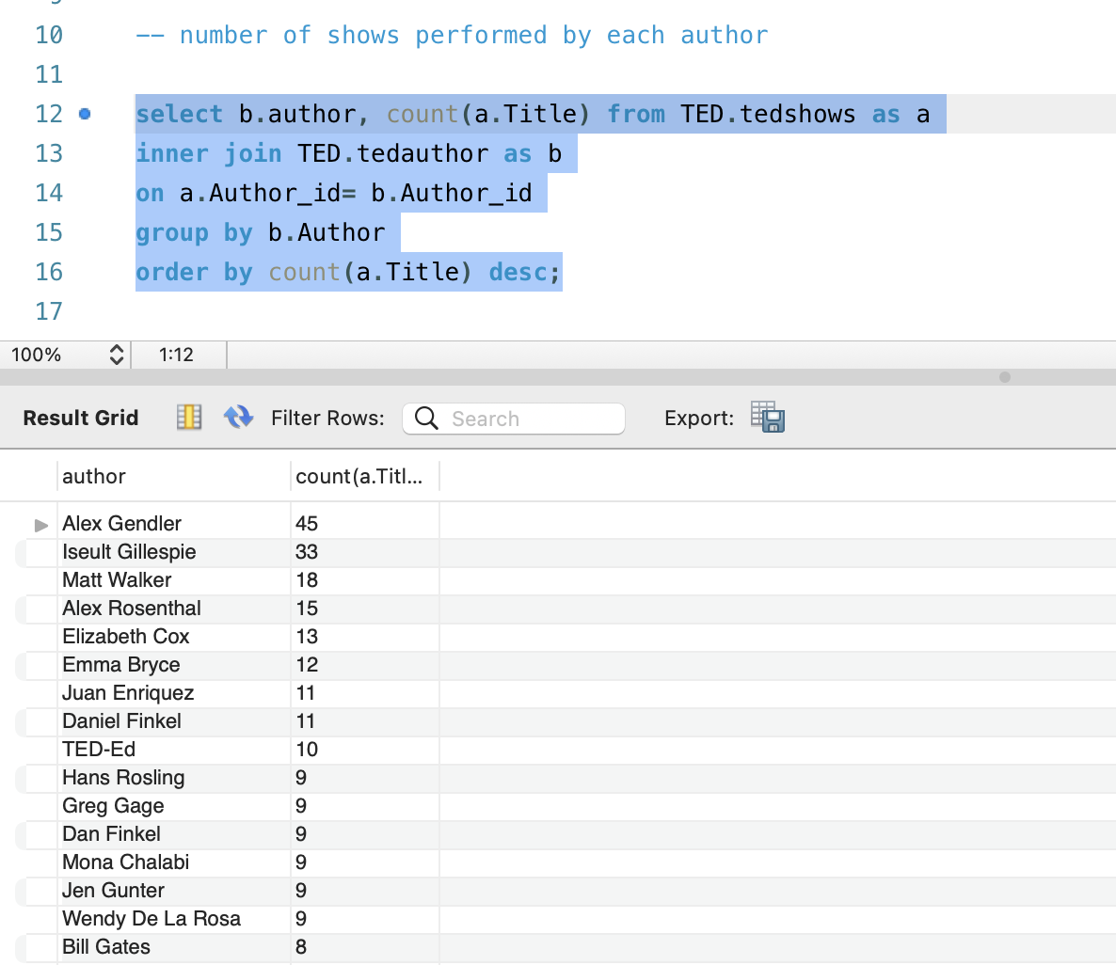

Looking at the above Query’s it is evident that the Likes and Views have a linear relationship. Moreover, the number of shows with one speaker are 5249, two speakers is 174, three speakers are 8, four speakers are 3, and five speakers is 1. In addition to this, we could say that the most of authors occupation is “Writer”. Although a greater number of shows are conducted in February month (i.e, 725 shows) and 2019 year (i.e, 544 shows), we could see that the average number of Likes and Views were more in the year 2006.

1. **DATA VIZUALIZATION USING TABLEAU:**

We have used Tableau for BI data visualization. Once the data is cleaned, we have connected the data to tableau server to perform Visualizations and analysis.

* Vizualization1: Top 10 Speakers based on Likes and Views.

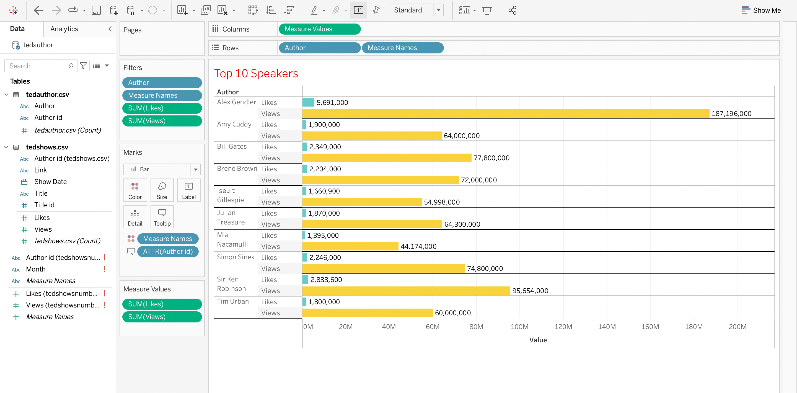

* Vizualization2: Bottom 25 Speakers.

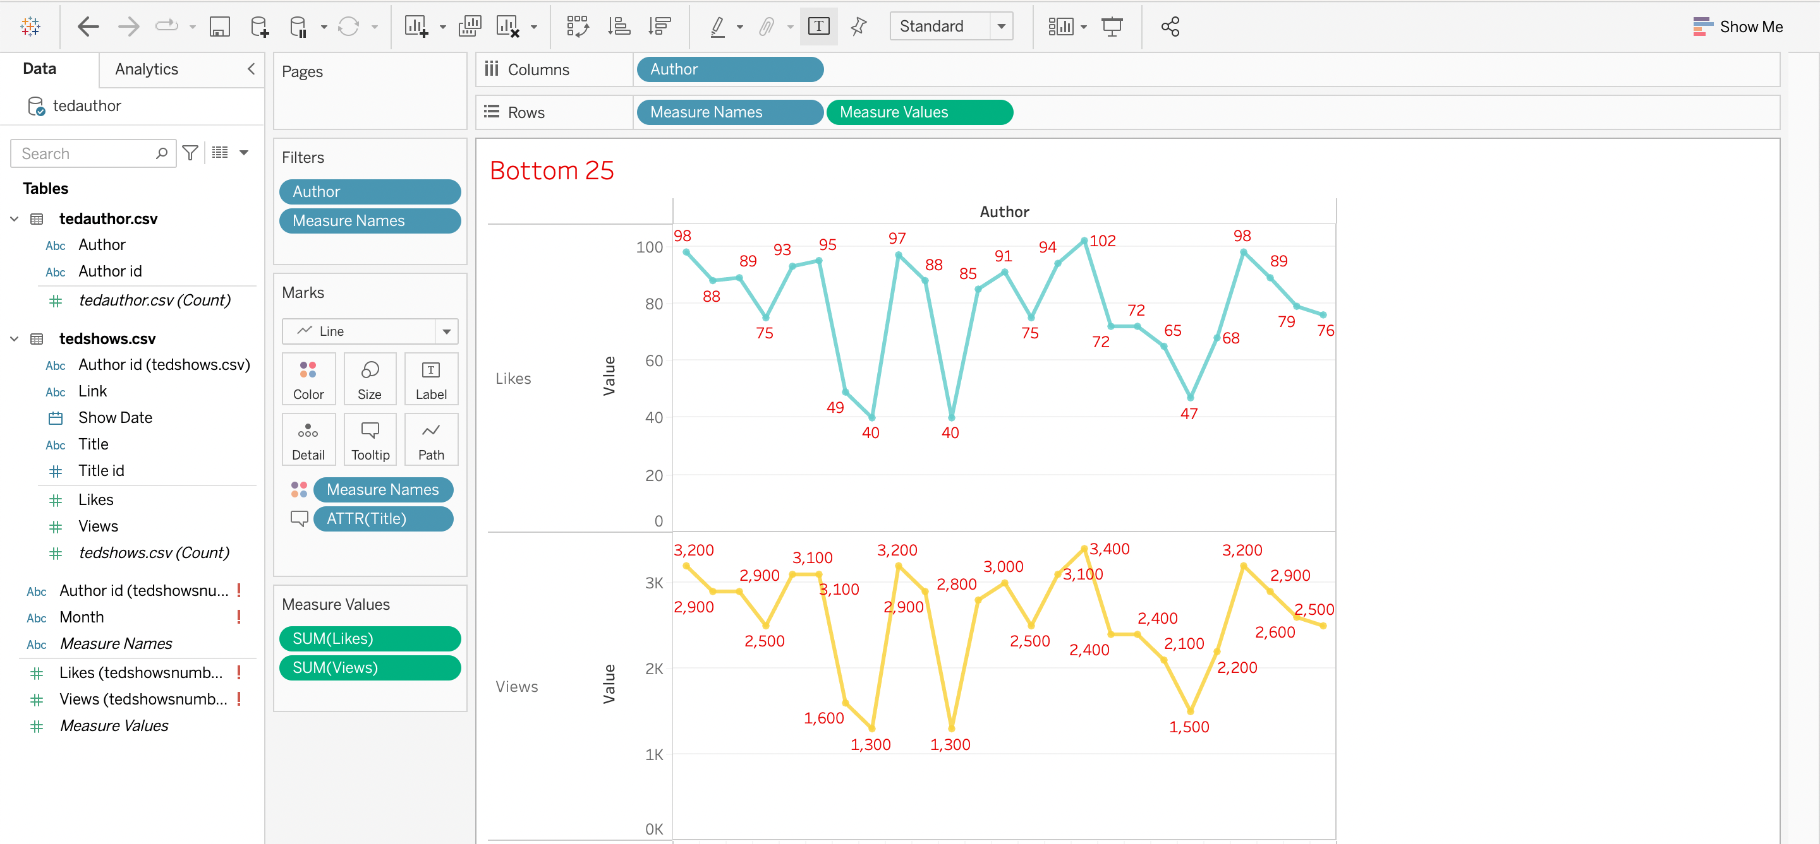

* Vizualization3: Likes & Views per Month.

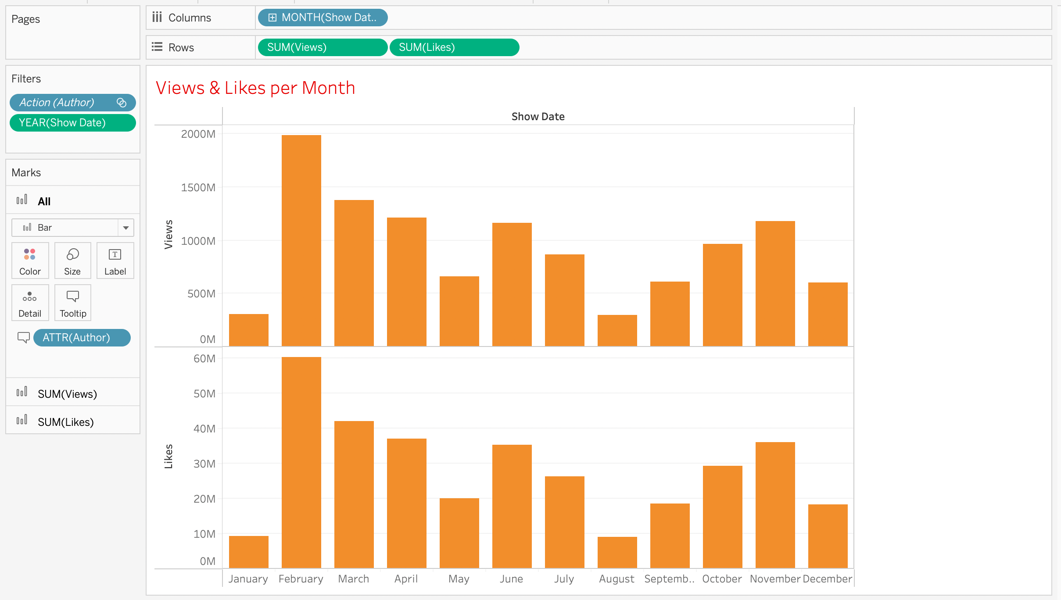

* Vizualization4: Views & Likes per Year.

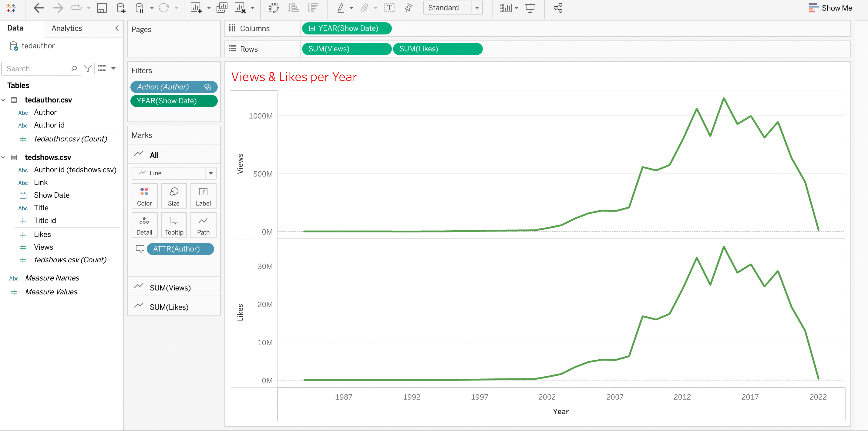

* Vizualization5: Likes per Speaker.

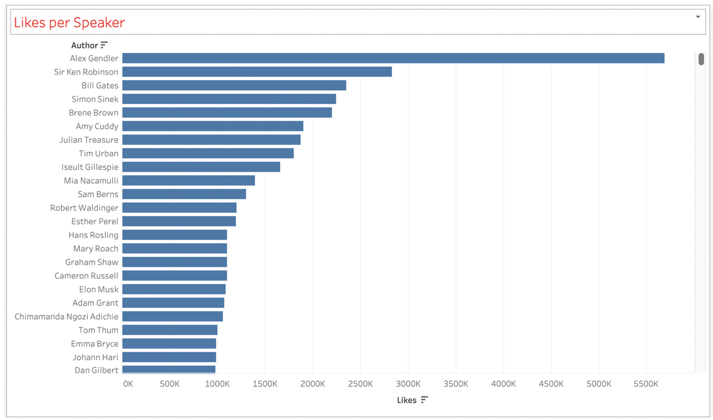

* Vizualization6: Views per Speaker.

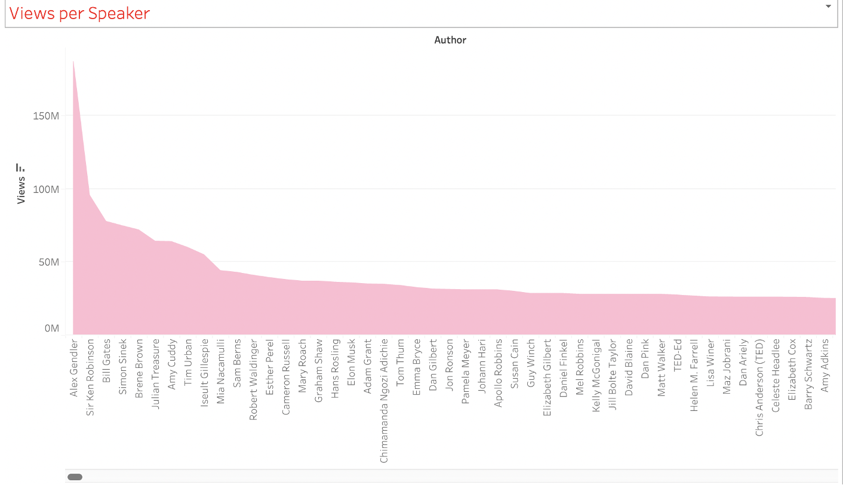

* Vizualization7: Speakers with more than Million Likes.

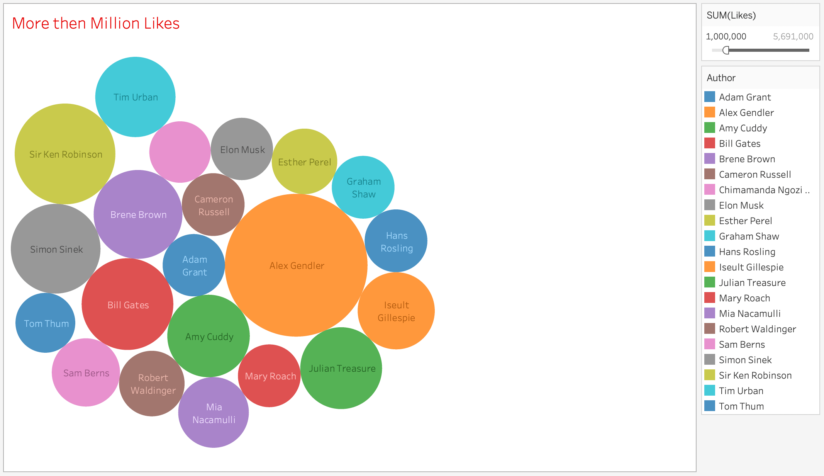

* Vizualization8: Ted shows per month.

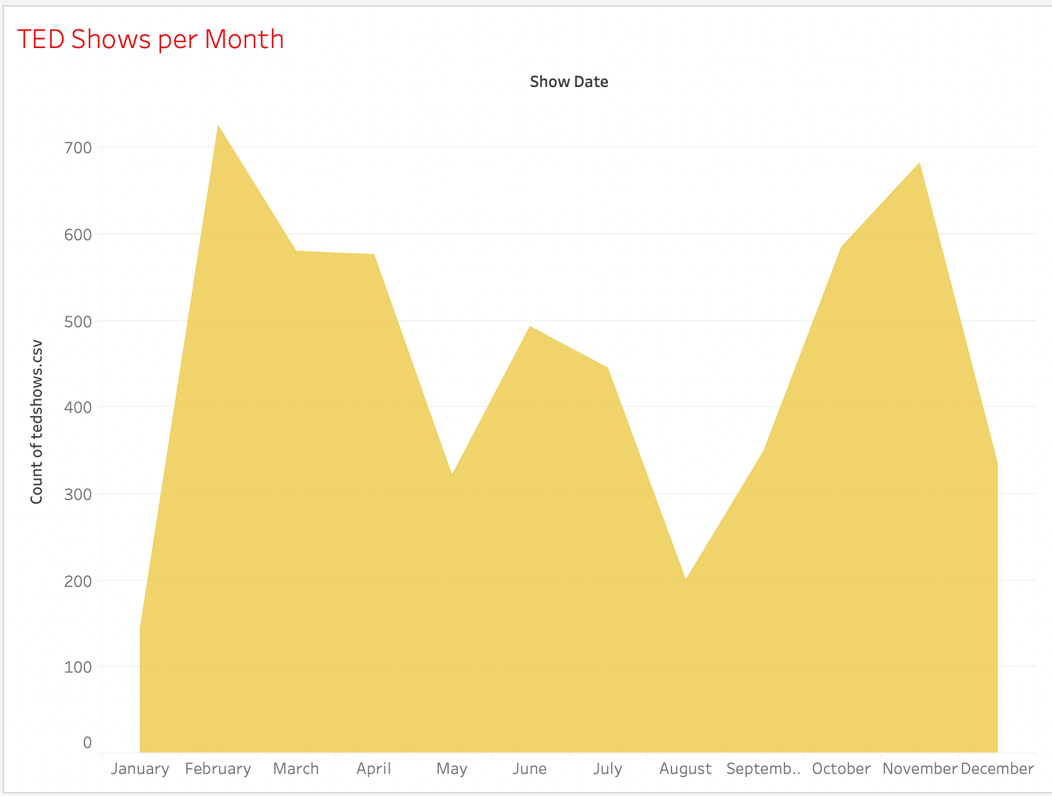

* Vizualization9: Month & Year wise data of the Top one Speaker of all the shows.

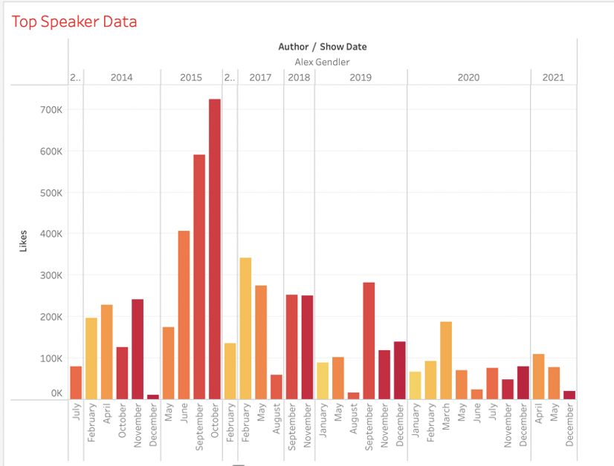

* Vizualization10: Average Views & Likes Per Year.

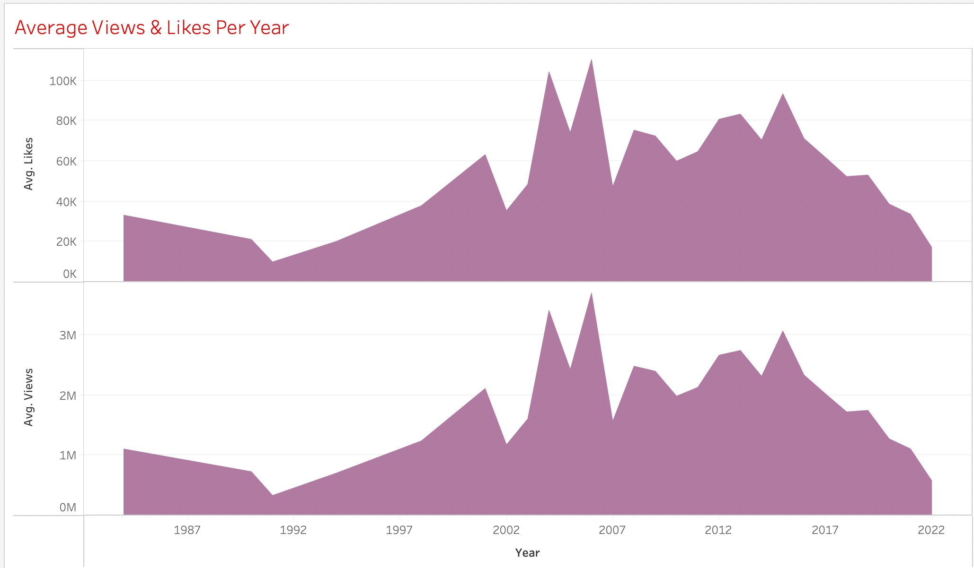

* Vizualization11: Dashboard

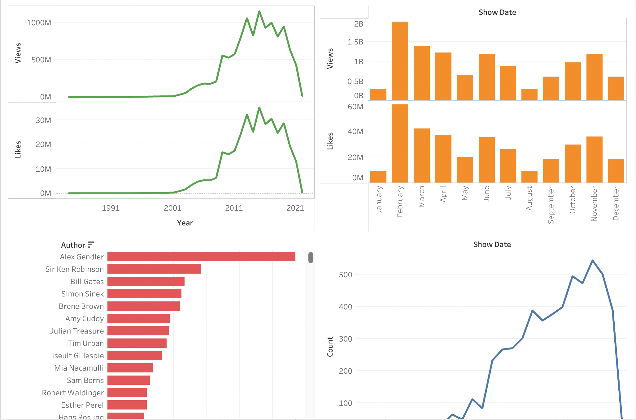

Based on the above Visualizations we can interpret that “Alex Gendler” has the greatest number of Views and Likes in the period 1984 to 2022 (i.e, performed 45 shows with 187,196,000 Views and 5,691,000 Likes). In April 2017, greatest number of views has been recorded. In addition to this, we could observe that every year in between February and April, the shows conducted has received the highest interest from the audience. We could assume from our analysis that the number of people watching the Ted talks show has been decreased gradually since April 2019. Also, Total number of views and Likes are highest in the year 2015 (i.e, 1,154,739,598 Views and 35,151,746 Likes).

**CONCLUSION:**

The Analysis uncovers that the ‘Alex Gendler’ has the greatest number of views & likes than any other author in the period from Feb. 1984 to Feb. 2022. The greatest number of views is recorded in the month of April 2017. Highest number of shows is recorded in Feb Month and in 2019 year. Average number of Views and Likes are more in the year 2006. Every year between Feb and April, the shows have received the highest interest from audience. It is safe to assume from our analysis that the number of people watching ted talks has decreased gradually since April 2019. Hence, they could take measures to increase the viewers for the shows as the trend is decreasing since April 2019.

**REFERENCES:**

[1]. Ashish Jangra, 2022, Kaggle TED TALKs

<https://www.kaggle.com/datasets/ashishjangra27/ted-talks>